Pls contact us :35007117@ qq.com
----------------------------------------------------------
Digital Temperature Module
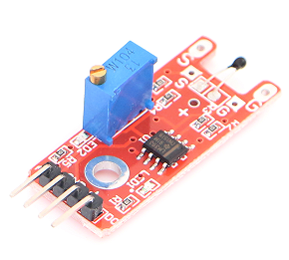
Digital Temperature module can connect UNO R3 PIN13, make Temperature test.
Pin 13’s LED，use Digital Temperature module connect Pin 3. When Digital Temperature module test there is Temperature , led can be bright.

Code：
int Led=13;//Define LED interface
int buttonpin=3; //Digital temperature sensor interface
int val;/Definition of digital variable val
void setup()
{
pinMode(Led,OUTPUT);//Define LED as output interfacepinMode(buttonpin,INPUT);//Define digital temperature sensor as output interface
}
void loop()
{
val=digitalRead(buttonpin);//Read the value of the value of the digital interface 3 to val
if(val==HIGH)//When the digital temperature sensor detects the signal, the LED flashes
{
digitalWrite(Led,HIGH);
}
else
{
digitalWrite(Led,LOW);
}
}

